TAIGUN TAIJUTSU RYUHA
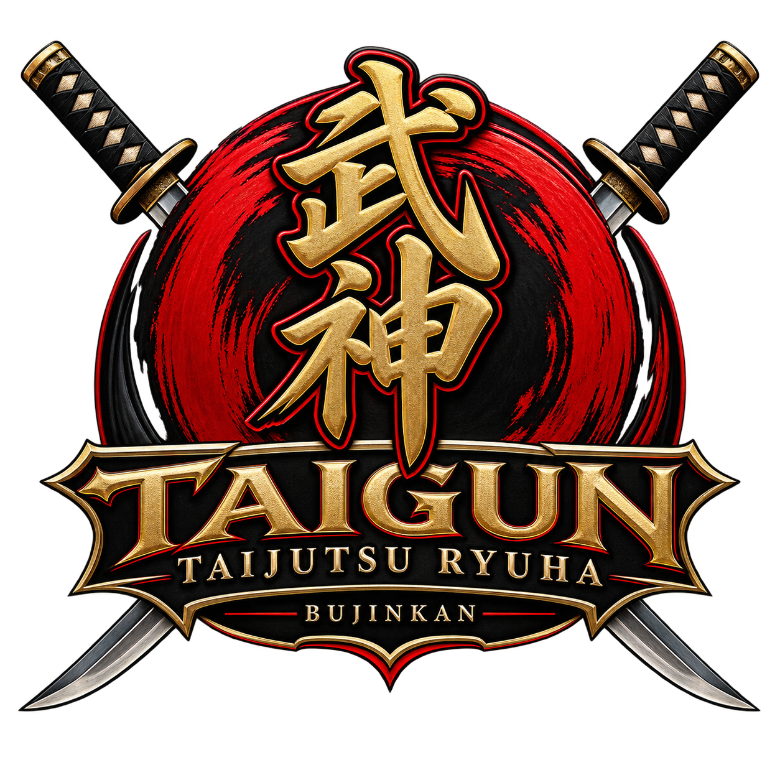

New Member Enrollment & Training Questionnaire
Traditional Bujinkan Budō Taijutsu Training
Thank you for your interest in training with Taigun Taijutsu Ryuha. This questionnaire helps us learn about your martial arts background, interests, goals, and expectations so we can determine whether our training environment is appropriate for you.

IMPORTANT — OUR TRAINING PHILOSOPHY
Taigun Taijutsu Ryuha is not a competition-oriented martial arts school. Our training is not centered around tournaments, trophies, points, or defeating another student for recognition.
Our approach emphasizes traditional Budō Taijutsu, personal development, discipline, awareness, effective movement, self-protection, and the responsible study of martial techniques.
Students are expected to train cooperatively, safely, respectfully, and with appropriate control. Techniques are practiced for learning and development—not to prove superiority over another student.

1. MEMBER INFORMATION
Full Name: ______________________________________________
Preferred Name: _________________________________________
Date of Birth: ___________________________________________
Phone: _________________________________________________
Email: __________________________________________________
Occupation (optional): ___________________________________
Emergency Contact Name: _________________________________
Emergency Contact Phone: ________________________________
Relationship: ___________________________________________

2. MARTIAL ARTS EXPERIENCE
Have you previously trained in martial arts?
☐ Yes
☐ No
If yes, please list the martial art(s), school(s), approximate length of training, and rank(s) earned:

Have you previously trained in any of the following? Check all that apply.
☐ Bujinkan Budō Taijutsu
☐ Ninjutsu / Ninpō
☐ Jujutsu / Jūjutsu
☐ Judo
☐ Karate
☐ Taekwondo
☐ Aikido
☐ Brazilian Jiu-Jitsu
☐ Wrestling
☐ Boxing
☐ Kickboxing / Muay Thai
☐ MMA
☐ Military combatives
☐ Law-enforcement defensive tactics
☐ Weapons training
☐ Other: ______________________________________
☐ No previous martial arts experience
Previous instructor(s), organization(s), or dojo(s):

What did you enjoy most about your previous training?

Why did you stop or why are you looking for a different training environment?

3. YOUR INTERESTS
What interests you about training with Taigun Taijutsu Ryuha?

What areas of training are you most interested in? Check all that apply.
☐ Traditional Budō Taijutsu
☐ Taijutsu / unarmed movement
☐ Striking
☐ Grappling and control
☐ Throws and takedowns
☐ Joint locks and escapes
☐ Self-protection
☐ Situational awareness
☐ Traditional weapons
☐ History and philosophy
☐ Physical conditioning
☐ Personal discipline
☐ Confidence and personal development
☐ Other: ______________________________________
What are your primary goals for martial arts training?

What would you most like to learn or improve?

What do you hope to gain from your first six months of training?

4. TRAINING EXPECTATIONS
Which statement best describes what you are looking for?
☐ Traditional martial arts training
☐ Practical self-protection skills
☐ Personal development and discipline
☐ Physical fitness and coordination
☐ Traditional weapons training
☐ A long-term martial arts path
☐ Rank advancement through consistent training
☐ A serious group of people with whom to train
☐ Other: ______________________________________
Are you primarily interested in competitive martial arts, tournaments, trophies, or sport fighting?
☐ Yes
☐ No
☐ Unsure
If yes, please explain what you are looking for:

NON-COMPETITION ACKNOWLEDGMENT
I understand that Taigun Taijutsu Ryuha is not a competition-focused martial arts school. I understand that training is not structured around tournaments, points, trophies, or competitive fighting.
I understand that students are expected to train with cooperation, respect, control, discipline, and concern for the safety of their training partners.
Initials: __________________

5. CONDUCT AND RESPONSIBILITY
Martial arts training requires trust between instructors and students. Students may be taught techniques that could cause injury if misused. Members are therefore expected to demonstrate maturity, good judgment, self-control, and respect for others.
Why do you want to learn martial arts techniques?

How would you describe your attitude toward safety and responsibility when training with another person?

Are you willing to follow instructor directions and established dojo safety rules?
☐ Yes
☐ No
Are you willing to train cooperatively with students of different experience levels?
☐ Yes
☐ No

6. CRIMINAL HISTORY / BACKGROUND SCREENING
Because our training requires trust, responsibility, and the safe practice of martial techniques, applicants may be asked to complete a background screening as a condition of membership.
Have you ever been convicted of, pleaded guilty to, or pleaded no contest to a criminal offense other than a minor traffic violation?
☐ Yes
☐ No
If yes, you may provide a brief explanation below:

A “Yes” response does not automatically determine membership eligibility. Relevant circumstances may be reviewed individually, including the nature of the offense, how long ago it occurred, and its relevance to the safety and responsibilities associated with training.
Additional information or authorization for a formal background check may be requested separately when appropriate and permitted by law.

7. APPLICANT STATEMENT
I certify that the information I have provided on this form is accurate to the best of my knowledge.
I understand that martial arts training involves physical contact and requires responsible behavior. I agree to follow dojo rules, instructor directions, and established safety procedures.
I understand that Taigun Taijutsu Ryuha emphasizes traditional martial arts training and is not a tournament or competition-based martial arts program.
I understand that membership and continued participation require appropriate conduct, respect for other students, and responsible use of the knowledge and skills taught.
Applicant Name (print): __________________________________
Applicant Signature: _____________________________________
Date: ______________________

FOR DOJO USE ONLY
Application reviewed by: _________________________________
Date: ______________________
Introductory training completed: ☐ Yes ☐ No
Background screening required: ☐ Yes ☐ No
Background screening completed: ☐ Yes ☐ No
Membership:
☐ Approved
☐ Approved with conditions
☐ Further discussion required
☐ Not accepted
Instructor Notes:

