TAIGUN TAIJUTSU RYUHA
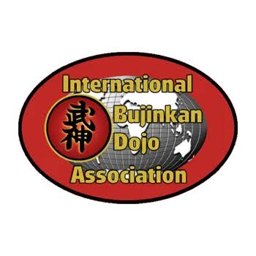
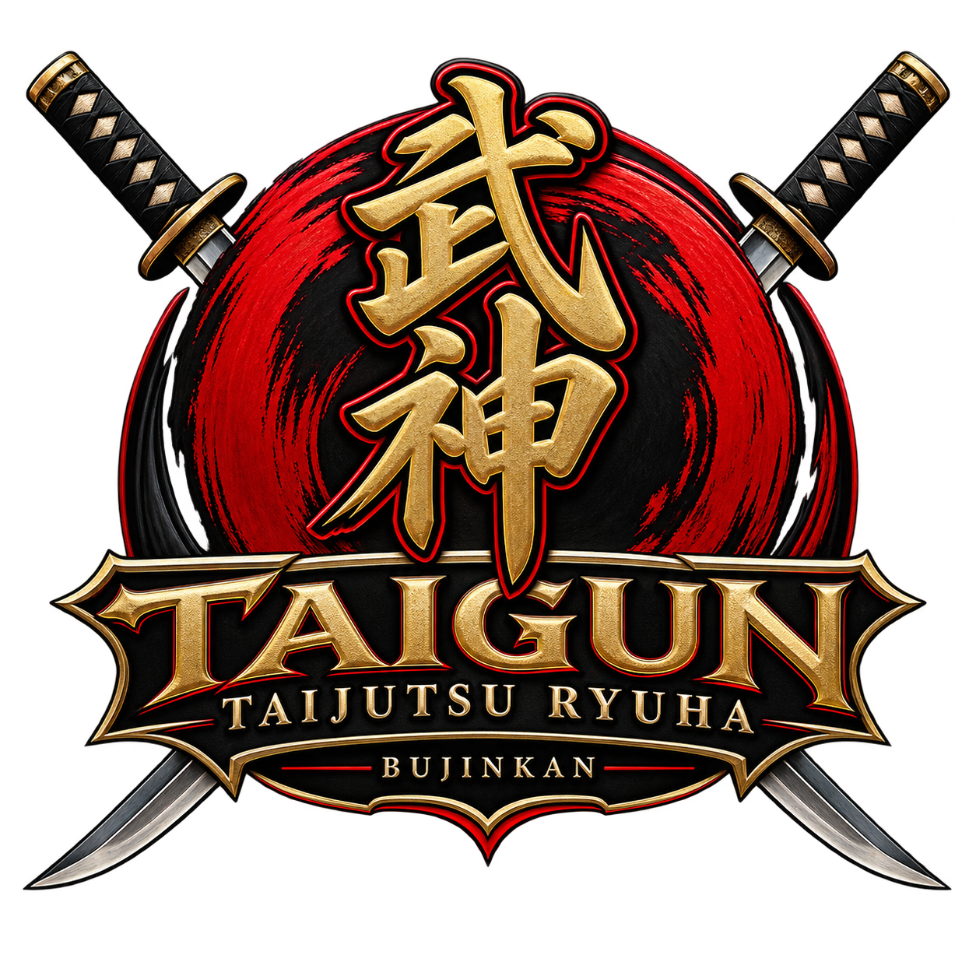

ASSUMPTION OF RISK, WAIVER AND RELEASE OF LIABILITY, MEDICAL AUTHORIZATION & PARTICIPANT AGREEMENT
PLEASE READ CAREFULLY BEFORE SIGNING. THIS DOCUMENT AFFECTS YOUR LEGAL RIGHTS.

PARTICIPANT INFORMATION
Participant Name: ______________________________________________
Date of Birth: ____________________ Age: ____________________
Address: ______________________________________________________
City/State/ZIP: _________________________________________________
Phone: ___________________________ Email: ______________________
Emergency Contact: _____________________________________________
Emergency Contact Phone: _______________________________________

1. VOLUNTARY PARTICIPATION
I understand and acknowledge that my participation in classes, seminars, training sessions, demonstrations, camps, Tai Kai, special events, private instruction, outdoor training, weapons training, and other activities conducted or sponsored by Taigun Taijutsu Ryuha is entirely voluntary.
I understand that I am not required to participate in any activity, drill, exercise, technique, or training scenario that I believe exceeds my physical abilities or presents an unreasonable risk to my safety.

2. ACKNOWLEDGMENT OF INHERENT RISKS
I understand that martial arts and related training are physical activities involving inherent risks that cannot be completely eliminated regardless of the care taken by instructors or participants.
These risks may include, but are not limited to:
- Falls, throws, rolling, grappling, joint manipulation, joint locks and restraint techniques;
- Striking, kicking, blocking and contact with other participants;
- Sprains, strains, bruises, cuts and abrasions;
- Broken or dislocated bones;
- Head, neck, back, spinal or joint injuries;
- Concussions or other traumatic injuries;
- Injury caused by accidental or unintended contact;
- Physical exertion, fatigue, dehydration or environmental exposure;
- Outdoor training on uneven, wet, wooded, rocky or otherwise hazardous terrain;
- Contact with training equipment, obstacles or structures;
- Training involving traditional martial-arts weapons or training replicas;
- Injury resulting from another participant's actions or failure to follow instructions;
- Equipment failure;
- Slips, trips and falls;
- Known and unknown medical conditions that may be aggravated by physical activity;
- Serious bodily injury, permanent disability, paralysis or death.
I understand that this list does not describe every possible risk associated with martial-arts training.

3. MARTIAL-ARTS AND WEAPONS TRAINING
I understand that Taigun Taijutsu Ryuha training may include traditional Bujinkan Budo Taijutsu and related martial-arts methods involving striking, grappling, throwing, joint manipulation, movement, falling, rolling, restraint methods and traditional weapons.
Depending upon the particular class, rank, event or training program, training equipment may include padded or training versions of traditional weapons and other martial-arts equipment.
I understand that even when training equipment and safety procedures are used, accidental contact and injuries can occur.
I agree that I will not handle or use any weapon, training weapon or other equipment unless authorized by an instructor and will immediately follow all instructor commands concerning its handling, use, storage and safety.

4. ASSUMPTION OF RISK
I KNOWINGLY AND VOLUNTARILY ACCEPT AND ASSUME THE INHERENT AND OTHER RISKS ASSOCIATED WITH MY PARTICIPATION IN THESE ACTIVITIES, WHETHER KNOWN OR UNKNOWN, FORESEEABLE OR UNFORESEEABLE, TO THE EXTENT PERMITTED BY TENNESSEE LAW.
I understand that serious injury or death is possible despite reasonable safety precautions.
I voluntarily choose to participate with knowledge of these risks.

5. RELEASE AND WAIVER OF LIABILITY
To the fullest extent permitted by Tennessee law, I voluntarily release and discharge Taigun Taijutsu Ryuha, its owner(s), instructors, assistant instructors, employees, volunteers, agents, representatives, event organizers, and, where applicable, owners or lawful occupiers of property used for training ("Released Parties") from claims arising from my participation in covered activities, including claims based upon the ordinary negligence of a Released Party, to the extent such claims may lawfully be released in advance under Tennessee law.
I understand that by signing this Agreement, I am giving up certain legal rights that I might otherwise possess.
THIS AGREEMENT IS NOT INTENDED TO RELEASE OR WAIVE LIABILITY THAT CANNOT LAWFULLY BE WAIVED UNDER TENNESSEE LAW, INCLUDING LIABILITY WHERE A RELEASE IS PROHIBITED BY APPLICABLE LAW.

6. PERSONAL RESPONSIBILITY
I agree to:
- Follow all safety rules and instructor directions;
- Train only at the level authorized by the instructor;
- Use equipment and training weapons only as instructed;
- Immediately report unsafe conditions, damaged equipment or dangerous conduct;
- Inform an instructor when I do not understand a technique or safety instruction;
- Stop participating whenever I believe I cannot safely continue;
- Refrain from reckless, intentionally dangerous or unauthorized conduct;
- Respect the safety and physical limitations of training partners; and
- Avoid participating while impaired by alcohol, illegal drugs or any substance that makes participation unsafe.
I understand that violation of safety rules may result in my immediate removal from training.

7. HEALTH AND FITNESS ACKNOWLEDGMENT
I understand that martial-arts training can be physically demanding.
I represent that, to the best of my knowledge, I am physically capable of participating in the activities I voluntarily undertake.
I understand that Taigun Taijutsu Ryuha and its instructors are not responsible for determining my medical fitness to participate.
I understand that I should consult an appropriate medical professional before participating if I have questions or concerns about my physical ability to train safely.
I agree to disclose to the instructor any physical limitation that affects my ability to participate safely, without being required to disclose unnecessary private medical information.

8. MEDICAL EMERGENCY AUTHORIZATION
If I become injured or experience a medical emergency and am unable to make decisions for myself, I authorize Taigun Taijutsu Ryuha personnel to contact emergency medical services.
I understand that instructors are not guaranteeing that medical assistance will be immediately available.
I understand that I am financially responsible for medical treatment, ambulance transportation, hospital services and other medical expenses incurred on my behalf, except where otherwise required by law.

9. PERSONAL PROPERTY
I understand that I am responsible for securing my personal property, including clothing, training equipment, weapons, electronics, vehicles and other belongings.
Taigun Taijutsu Ryuha is not responsible for lost, stolen or damaged personal property except to the extent liability cannot legally be excluded.

10. PRIVATE PROPERTY AND OUTDOOR TRAINING
I understand that some training or events may occur on privately owned property and may involve outdoor terrain and natural or artificial hazards.
I agree to remain within authorized training areas and obey all property, safety, parking, camping and event rules.
I understand that entering unauthorized areas or engaging in unauthorized activities may result in removal from the property.

11. RULES AND CODE OF CONDUCT
I understand that participation is a privilege and that Taigun Taijutsu Ryuha may establish reasonable rules designed to protect participants, instructors, visitors and property.
Unsafe, threatening, intentionally harmful, reckless or disruptive behavior may result in suspension or termination of participation.

12. TENNESSEE LAW
This Agreement shall be interpreted under the laws of the State of Tennessee, to the extent permitted by applicable law.
If any provision of this Agreement is determined to be invalid or unenforceable, the remaining provisions are intended to remain in effect to the fullest extent permitted by law.

PARTICIPANT ACKNOWLEDGMENT
I ACKNOWLEDGE THAT I HAVE CAREFULLY READ THIS ENTIRE AGREEMENT BEFORE SIGNING IT.
I UNDERSTAND THAT MARTIAL-ARTS TRAINING INVOLVES RISKS OF SERIOUS INJURY, PERMANENT DISABILITY AND DEATH.
I UNDERSTAND THAT THIS AGREEMENT CONTAINS AN ASSUMPTION OF RISK AND A RELEASE AND WAIVER OF CERTAIN LEGAL CLAIMS, INCLUDING CERTAIN CLAIMS INVOLVING ORDINARY NEGLIGENCE, TO THE EXTENT PERMITTED BY TENNESSEE LAW.
I HAVE HAD THE OPPORTUNITY TO ASK QUESTIONS BEFORE SIGNING THIS AGREEMENT.
I AM SIGNING THIS AGREEMENT FREELY AND VOLUNTARILY.
Participant Printed Name: _______________________________________
Participant Signature: __________________________________________
Date: ______________________________
Instructor/Authorized Representative: _____________________________
Signature: ____________________________________________________
Date: ______________________________

OPTIONAL WITNESS
Witness Printed Name: __________________________________________
Witness Signature: _____________________________________________
Date: ______________________________

